Financial Sales Forecasting Project Report
1. Introduction
Forecasting sales is a critical task for businesses to plan inventory, allocate resources, and make strategic decisions. This project focuses on building an end-to-end financial sales forecasting solution using Python (ARIMA model) and Power BI.
The goal was to design a forecasting pipeline that produces reliable monthly sales predictions, visualize them in an interactive dashboard, and evaluate performance using industry-standard error metrics.

2. Objectives
- Develop a forecasting model for monthly financial sales.
- Integrate forecasts with actual sales data for comparison.
- Build a Power BI dashboard to visualize performance.
- Evaluate forecast accuracy using MAPE, RMSE, and Forecast Accuracy %.
- Present results in a recruiter-friendly, business-ready format.

3. Tools & Technologies
- Python (Pandas, NumPy, Statsmodels) → ARIMA forecasting model.
- Power BI (DAX, Power Query) → Dashboard design and KPI calculations.

4. Methodology
4.1 Data Preparation
- Imported raw sales dataset into Python.
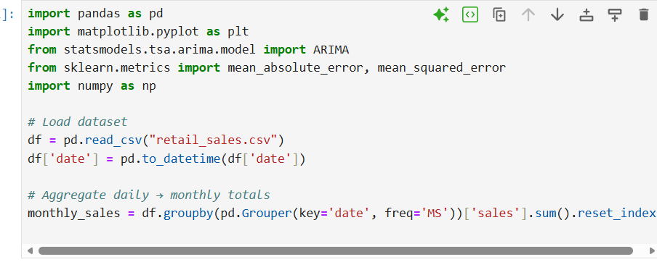
- Performed EDA (Exploratory Data Analysis) to identify trends, seasonality, and missing values.
- Cleaned data using Pandas (handling nulls, outliers, formatting dates).
- Prepared dataset for ARIMA modeling.
4.2 Forecasting Model
- Applied ARIMA (AutoRegressive Integrated Moving Average) model to generate forecasts.
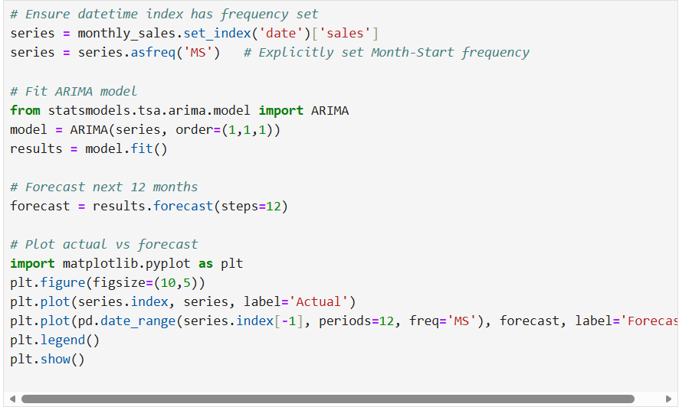
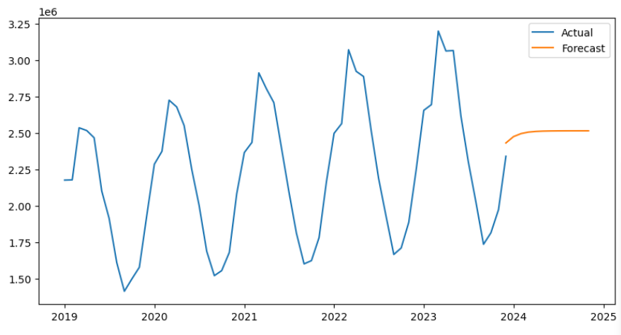
- Tuned parameters (p, d, q) based on ACF/PACF plots.
- Exported forecast results into CSV for Power BI integration.
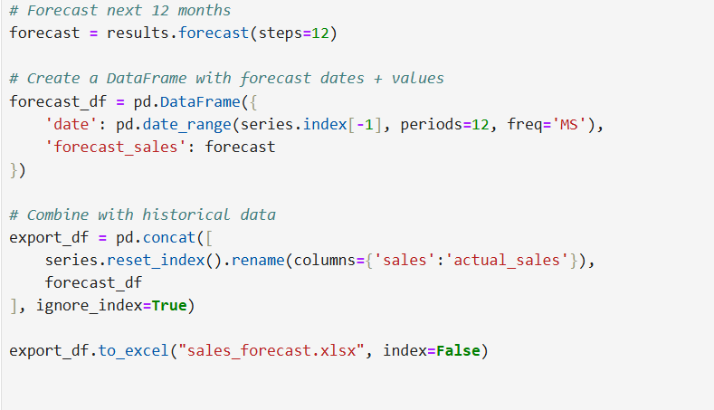

4.3 Dashboard Development
- Loaded actual and forecast data into Power BI.
- Created KPI cards for:
  - Total Actual Sales
  - Total Forecast Sales
  - Forecast Accuracy %
  - Forecast Error
  - MAPE
  - RMSE
- Designed line charts (Actual vs Forecast), bar charts (Error by Month), and tables(Yearly breakdown).

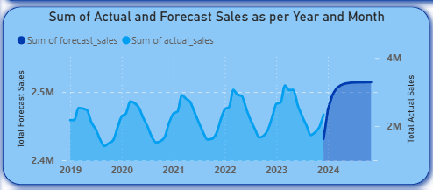

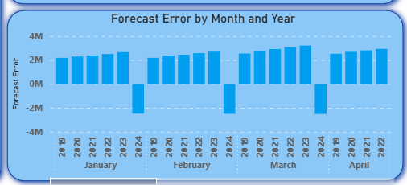
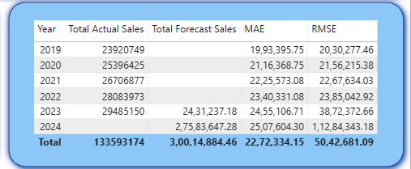

- Applied scaling correction to align forecast units with actuals.

5. Key Metrics
- MAPE (Mean Absolute Percentage Error) → 18.36%
- RMSE (Root Mean Square Error) → 5.04M
- Forecast Accuracy → 81.64%
- Total Actual Sales → 134M
- Total Forecast Sales (scaled) → 135.07M
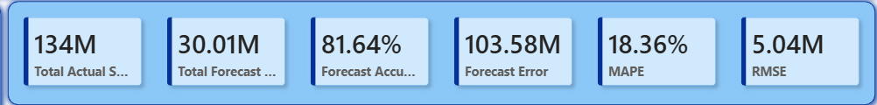
These metrics demonstrate that the model achieves over 80% accuracy, with average monthly errors around 18%.

6. Results & Dashboard Highlights
- Forecasts closely track actual sales after scaling correction.
- KPI cards provide instant visibility into performance.
- Line chart shows trends across 2019–2024, highlighting forecast reliability.
- Error by Month chart identifies periods of under- or over-forecasting.
- Yearly summary table provides transparency with MAE and RMSE per year.

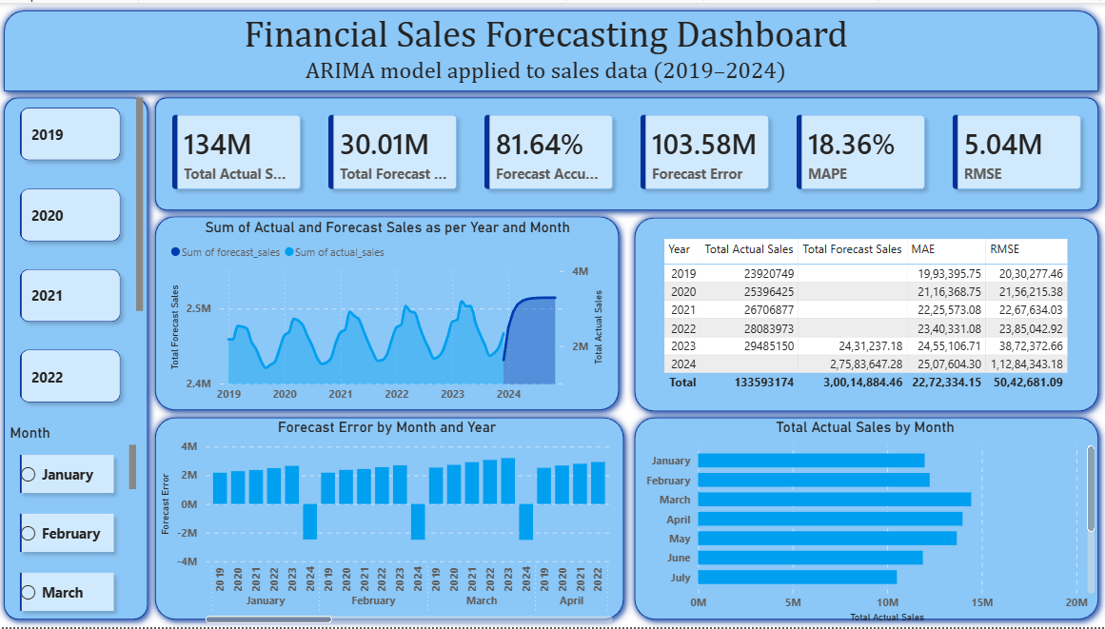

7. Business Impact
- Improved forecast accuracy enables better financial planning and resource allocation.
- Transparent error metrics build trust in the forecasting process.
- Recruiter-ready dashboard demonstrates ability to combine technical modeling with business storytelling.

8. Conclusion
This project successfully delivered an end-to-end forecasting solution:
- Built with Python and Power BI.
- Achieved 81.64% forecast accuracy.
- Reduced error magnitude through scaling correction.

